SR-5 Solutions

Challenge: In 21st Century, we are still facing different kinds of social and environmental issues. For instants, chemical, solid and hazardous waste (Electronic waste); water and air pollution; deforestation; species conservation-invasive species, etc.. Many organizations and social enterprises are fighting with those issues. However, some of them often do not have the resources or financing support to focus on building their capacity, even they have excellent ideas and strategies. For example, it is estimated that about 4 million tons E-waste are generated in the U.S. yet only 850,000 tons of them are to be recycled, and E-Waste Recycling Funding Deficit is 2 billion dollars in the U.S.

Solution: We suggest a new type of SR-5 visa that brings foreign investors’ attentions to social/environmental issues, and meanwhile introduce SR-5 Solutions. SR-5 Solutions closes a financing gap and acts as a catalyst for the comprehensive distribution of creative ideas and solutions for the better. Through building up links among resources, it provides verified Benefit Corporations—A type of for-profit entities that wish to consider society and the environment in addition to profit in their decision-making process—support, when it is not possible to acquire traditional sources of capital. This vehicle has rigorous investment criteria that ensure investments are viable and sustainable. In other words, SR-5 solutions works in meaningful ways that not only helping social impact businesses gain steady growth, but also maximizing economic and social/environmental impact returns. In the meantime foreign investors can expect stable return from investing in SR-5 Solutions and pursue their American dreams.
Scale: Market size is huge because the U.S.’s sustainable investment market is large; SR-5 Solutions is aiming at reaching a scalable size of $1 billion, which will further lead to a broader social impact.

Strong funding source: SR-5 Solutions expects 1,000 investment applications in three years, to achieve the funding size of $1 billion.

Being socially responsible: SR-5 investors can expect stable returns. Direct capital investments are expected to generate more than 20,000 working positions, and American social impact businesses will benefit from SR-5 Solutions.

SR-5 Visa: A type of visa invented by SR-5 Solutions team. It has similar working mechanism as EB-5 visa. In addition, SR-5 investors are expecting to invest in social/environmental impact businesses (Benefit Corporations).

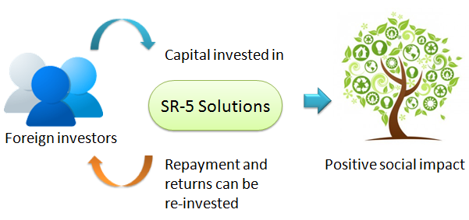

SR-5 Solutions: Requires 10 year vesting period, and has two business functions:
SR-5 Social Enterprise Incubator—provides whole process service to startup social businesses;
SR-5 Impact Fund—long-term equity investment vehicle that helps already proven social enterprises grow fast

